Module 2: Individual Insurance Products

Lesson 1: Term Life Insurance

Learning Objectives

After studying this lesson, you will be able to:
- Describe term life insurance (bảo hiểm tử kỳ) coverage (phạm vi bảo hiểm) and distinguish between level term (tử kỳ cố định), decreasing term (tử kỳ giảm dần), and increasing term (tử kỳ tăng dần) life insurance plans.
- Describe the operation of a return of premium (ROP) term policy (cách hoạt động của bảo hiểm tử kỳ hoàn phí)
- Explain how the renewal (gia hạn) and conversion (chuyển đổi) features included in some term life policies increase their value to customers.

Term Life Insurance

Learning Objective
Describe term life insurance coverage and distinguish between level term, decreasing term, and increasing term life insurance plans.

Financial Needs Met by Life Insurance
(Nhu cầu tài chính đáp ứng bởi công ty bảo hiểm)

What do you think

Assume that Carter has life insurance on his own life. Select the box beside each financial need that you think life insurance can meet.
- Paying household expenses (utility bills, food, clothing, etc.)
- Covering outstanding debts (mortgage and car loans, etc.)
- Paying future outstanding medical, hospital, and funeral expenses
- Providing financial support for the family
- Funding a child’s education
Answer: All is correct
Explanation: Proceeds can help cover household expenses and expenses related to Carter’s death that aren’t covered by other insurance. Carter’s wife Bridget won’t have to sell assets from Carter’s estate to pay off his debts; she can also use the proceeds to pay any private school and/or college. Finally, life insurance proceeds can support the family until Bridget can find new sources of income or can adjust to a lower income.

What is Term Life?
Carter needs financial protection for his wife and children in case he should die unexpectedly. His wife Bridget also needs financial protection for Carter and the children.
Term life insurance (Life insurance that provides a death benefit only if the insured dies during the period specified in the policy.), which provides coverage for a specified period of time, is one product that could help meet Carter’s needs.

No. For starters, the policy term varies from policy to policy. Three examples:
- Flight insurance that insures a passenger's life during one airplane trip
- A life insurance policy that insures a person for 20 years
- A life insurance policy that insures a person until she reaches age 65
Few policy terms are shorter than one year.

Types of Term Life Insurance

Level Term Insurance
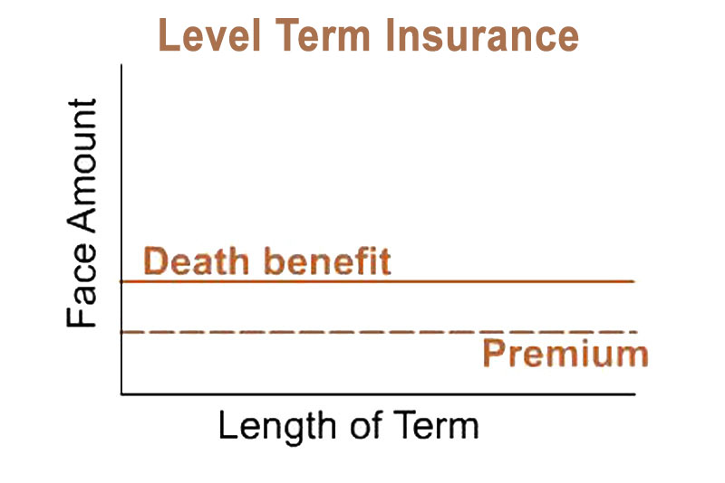
In level term life insurance (Term life insurance that provides a policy benefit that remains the same over the term of the policy.), the policy benefit—and usually the premium—remain the same over the policy term. Level term life is the simplest form of term life insurance. It provides temporary life insurance protection on a limited budget, which makes it a good choice for many insureds. They can purchase large amounts of level term life for a relatively small premium. And because the face amount and the premiums usually remain the same throughout the policy term, there’s no guesswork with level term.

Decreasing Term Insurance
In decreasing term life insurance (Term life insurance that provides a policy benefit that decreases in amount over the term of coverage.), the policy benefit decreases at stated intervals, but the premium amount usually remains the same. Decreasing term life is popular for people who have a financial need that decreases in amount over a defined time.
A common form of decreasing term is mortgage insurance (A plan of decreasing term insurance designed to provide a benefit amount that corresponds to the decreasing amount owed on a mortgage loan. )—the decreasing benefit corresponds to the decreasing balance on a mortgage loan.
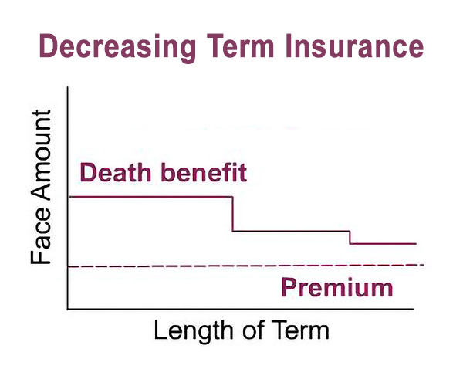

What do you think?
- When Michael bought a house, he obtained a mortgage loan from the Archway Bank. He also bought a mortgage insurance policy from Able Life.
Is Archway Bank a party to Michael’s mortgage insurance contract with Able Life?
- Yes
- No

Answer: No
Explanation: The mortgage loan and the insurance contract are separate transactions. The insurer is not a party to the mortgage loan and the bank is not a party to the mortgage insurance policy.

- Who can Michael name as the beneficiary of his mortgage insurance policy?
- His wife only
- Archway Bank only
- His wife, Archway Bank, or someone else
Answer: His wife, Archway Bank, or someone else
Explanation: Michael can name the bank as the beneficiary of his mortgage insurance policy, but he’s not required to. Usually, policyowners name their spouse or a family member as beneficiary.

- If Michael names his wife as the policy beneficiary, does she have to use the policy proceeds to repay the mortgage loan?
- Yes
- No
Answer: No
Explanation: She can use the proceeds to repay the mortgage loan, but she isn’t required to.

Other types of decreasing term life:

Credit life insurance - Pays the balance on relatively short-term loans (such as automobile, education, home equity, and personal loans). The policy benefit decreases as the loan balance does. Unlike mortgage insurance, credit life insurance proceeds are always payable to the lender or creditor.

Family income coverage - Pays a stated monthly income benefit amount to the beneficiary if the insured dies during the term of coverage. Monthly benefits continue until the end of the term specified when the coverage was purchased. The longer the insured lives, the shorter the monthly benefit period and the smaller the benefit amount.

Example:
Elisabeth Romero bought 10-year family income coverage that provides a $1,000 monthly income benefit payable to her husband. Elisabeth died six years after buying the family income coverage.
Analysis:
Since Elisabeth died six years after buying the coverage, the insurer will pay the monthly income benefit for the remaining four years of the family income coverage.

Increasing Term Insurance
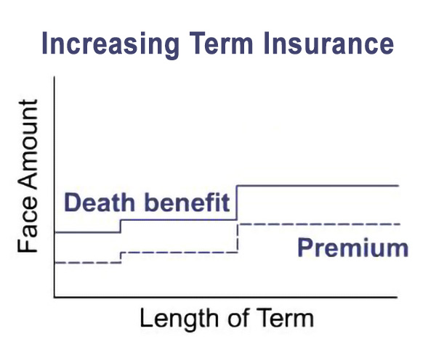
In increasing term life insurance, the policy benefit (and the premium) start at one amount and increase at stated intervals because some financial needs increase with time.
For example, if Carter’s son attends private high school, tuition would likely rise each year, and college expenses might be even higher. Increasing term life could help pay for his son’s education if Carter dies before the child is out of college. This type of policy would make sense if the term ended when Carter’s child is expected to finish school.

Let’s review

Decide whether the statements below describe increasing term insurance, level term insurance, or decreasing term insurance.

- A 5-year term life insurance policy that offers a death benefit of $50,000 for the first year of the policy term, $40,000 for the second year, and so on. The benefit for the fifth year is $10,000.
- ^{Increasing term insurance}
- ^{Level term insurance}
- ^{Decreasing term insurance}
Answer: Decreasing term insurance
- A 5-year term life insurance policy that provides a $100,000 death benefit if the insured dies at any time during the 5-year policy term.
- ^{Increasing term insurance}
- ^{Level term insurance}
- ^{Decreasing term insurance}
Answer: Level term insurance
- A 5-year term life insurance policy that pays a $100,000 benefit during the policy's first year, a $105,000 benefit during the second year, and so on. The benefit during the fifth year is $120,000.
- ^{Increasing term insurance}
- ^{Level term insurance}
- ^{Decreasing term insurance}
Answer: Increasing term insurance

Other Term Insurance Features

Learning Objective
- Describe the operation of a return of premium (ROP) term policy.
- Explain how the renewal and conversion features included in some term life policies increase their value to customers.

Return of Premium (ROP) Insurance

Return of premium (ROP) term insurance is a type of term coverage that
- Pays a death benefit if the insured dies within the policy term
- Returns all premiums paid on the policy if the insured is still alive at the end of the policy term
The premiums for ROP term life coverage are usually higher than the premiums for comparable traditional term insurance.
See as this actuary explains return of premium (ROP) term insurance from the company's point of view.

When you're looking at return of premium type products, essentially the company is taking premiums and investing them and if there's an event that occurs, obviously they pay the death benefit out. But if there is no event at the end of the term period, the company is hoping that they've earned enough investment income that by returning the premium they've made a profit margin.
It's very attractive to a client who feels like "Okay, I got the protection and I get all my money back after 20 years." In a very low-interest rate environment that we're in today, these products are very difficult to price effectively but the concept is very, very popular still with many different market segments. So some carriers still keep it out there.
Now there have been certain rules and regulations that eliminate the ability to just pay out one set of cash values at the end of 20 years. So there's non-forfeiture regulations that don't allow that type of, you get zero for 19 years and then your 20th year, boom you get this windfall. So there's been regulations developed, once again as an actuary, you have to understand the new regulations that come up, that now will grade into that amount over time.
It's not such a tontine, it's made the prices go up a little bit more on these products, but in theory, people like to know that if they didn't use something, they didn't lose everything. So you see a lot of product development happening in that arena.

Renewable Term Life Insurance

Renewable term insurance lets you continue the coverage for another policy term without presenting evidence of insurability—proof that the insured person continues to be an insurable risk. There are some limitations (caveats), though.

What do you think?
Suppose Carter buys a renewable term insurance policy. Do you think he can renew the policy as many times as he wants?
- ^{Yes}
- ^{No}
- Can't tell. Need more information.

Answer: No
Explanation: As long as the policyowner pays the premiums due, a renewable term policy will automatically renew for another term—usually the same length as the original term. The policyowner can also renew for a shorter term. However, a term policy can be renewed only a maximum number of times or until the insured reaches a maximum age limit.
One advantage of renewable term insurance is that the policy is still renewable even if the insured’s health has declined. The insured doesn’t have to show evidence of insurability—proof that he is still insurable—to renew the policy.

Assume Blythe Owens owns a $100,000 20-year renewable term policy that she bought when she was age 35.
At age 55, she can automatically renew the policy for another 20-year term, even if she has developed health problems that might otherwise prevent her from getting coverage.

Suppose Blythe renews her $100,000 20-year renewable policy at the end of the policy term. Do you think the amount of coverage is automatically cut in half to $50,000?
- ^{Yes}
- ^{No}
- Can't tell. Need more information.

Answer: No
Explanation: The amount of coverage typically remains the same after policy renewal. So if the original 20-year term policy had a face amount of $100,000, the renewed 20-year term policy will also have a face amount of $100,000. Blythe can choose to renew the policy for a smaller amount, but not for a larger amount.
However, Blythe will have to pay a higher premium for the renewed policy than she was paying for the original policy. The renewal premium is based on the insured’s attained age at the time of renewal, rather than the age of the insured when the original policy was purchased.

Convertible Term Life Insurance
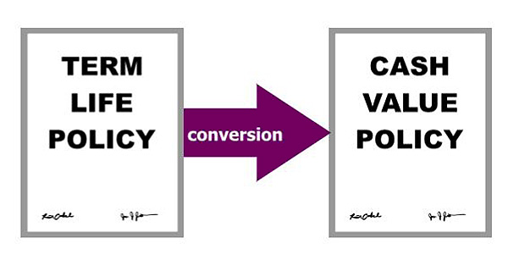
Convertible term insurance (Term life insurance that gives the policyowner the right to convert the term policy to a cash value life insurance policy without providing evidence of insurability.

) lets the policyowner convert, or change, a term life policy to a different type of policy—a cash value policy that provides the insured with lifetime coverage.
As with renewable term policies, convertible term policies have some limitations...

A conversion provision allows a policyowner to convert a term policy to a permanent policy during a specified conversion period, which is shorter than the duration of the term insurance coverage.
Once the conversion period expires, the policy is no longer convertible.

Term Conversions
See as this industry expert explains how convertible term insurance can be marketed and how company representatives encourage policyowners to convert their term coverage to permanent coverage.
So often when people are looking to purchase their first life insurance policy they're looking to get the most death benefit for the smallest amount of premium, and term really fits that bill. But one of the things that we encourage people to consider is the ability to convert that term to a permanent product in the future. Something to look at when you're purchasing a term product is does it have a conversion feature, which will allow you to convert to a whole life product with that company without any underwriting. That can really be a nice benefit for later when you have additional dollars that you can put towards your financial security, and start building that cash value, and being able to take advantage of the flexibility that permanent whole life product may offer.
Often what we see is reps, the first product they offer is a term product, and then they will say, but we'll be coming back at some point in the future to talk about converting it. They set that up to start with. Another thing to consider too when you're looking at a term conversion is what are the restrictions if any that that company has?
Generally, any product that we have available is available to have a term conversion too with a few exceptions. Some companies may restrict that more. So again, just something to look at as you are considering where to purchase that term product.
The conversion period usually are not unlimited. There is usually an end date for that conversion period. It also provides a great marketing opportunity for our financial reps. They can say "Hey, this is your last chance to convert your term product to a permanent. It's now or never." We do have quite a few that come in right at the deadline.

What do you think?
- Assume Blythe Owens purchased a convertible term insurance policy instead of a renewable term policy. During the conversion period, Blythe’s health declined to the point where she would no longer be considered insurable. Can Blythe convert her term policy to a cash value policy?
- ^{Yes}
- ^{No}
- Can't tell. Need more information.
Just like with renewable term life insurance, the insured doesn’t have to demonstrate evidence of insurability to convert the term policy to a cash value policy, and the insurer can't increase the premium rate for risk factors relating to the insured’s health. Premium increases can be based only on increased mortality risk associated with age.

Conversion Amount
Insurers limit the amount of converted cash value coverage to a percentage of the original term policy's face amount.
Typically, the policyowner can convert the full face amount of term coverage to cash value coverage within the first few years following policy issue. However, as the end of the conversion period gets closer, the convertible amount often decreases.

Convertible Term Premiums
Unlike premiums for renewed term coverage, premiums for converted policies aren’t always based on the insured’s attained age.
Convertible term policies allow for either an attained age conversion (A conversion of a term life insurance policy to a cash value life insurance policy in which the premium rate for the cash value policy is based on the insured's age at the time the policy is converted. Contrast with original age conversion) or an original age conversion (A conversion of a term life insurance policy to a cash value life insurance policy in which the premium rate for the cash value policy is based on the insured's age when the original term life insurance policy was issued. Contrast with attained age conversion.), which bases new premium rates on the insured’s age at the time the original policy was issued.
This is attractive to customers because premiums are lower when the insured is younger. Original age conversions do have some strings attached, though....

Attained Age vs. Original Age Conversion
Example: Marcia and Todd, each age 30, purchased 30-year convertible term life insurance policies. Both of them decided to convert their term policies to cash value policies at age 40.
Marcia decided to convert her term policy on an attained age basis.

Attained Age Conversion
The effective date of cash value coverage is the date of conversion.
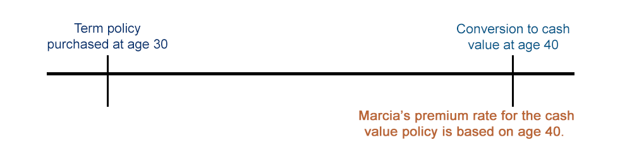

Original Age Conversion
Todd decided to convert his term policy on an original age basis.
The effective date of cash value coverage is the term policy purchase date.
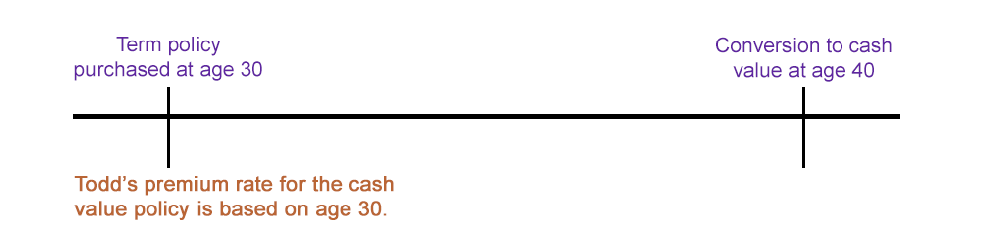
The renewal and conversion privileges can lead to some antiselection; insureds in poor health will be more likely to renew or convert their policies because they may not be able to obtain other life insurance coverage.
To account for the risk of antiselection, insurers charge higher premiums for renewable or convertible term policies than for comparable term policies that aren’t renewable or convertible.

Let’s review

Identify how renewal affects a term life insurance policy by selecting the correct answer. Note that some features have more than one correct answer.

- When a term life insurance policy is RENEWED, the amount of coverage under the policy can ...
- ^{increase}
- ^{decrease}
- ^{remain the same}
Answer: decrease, remain the same
Explanation: Renewal coverage can be for the same face amount as the original policy or smaller, but not for a larger face amount.
- When a term life insurance policy is RENEWED, the coverage period can ...
- ^{increase}
- ^{decrease}
- ^{remain the same}
Answer: decrease, remain the same
Explanation: Renewal coverage term can be same length as the original policy or shorter, but not longer.
- When a term life insurance policy is RENEWED, the premium rate (for the same amount of coverage) can ...
- ^{increase}
- ^{decrease}
- ^{remain the same}
Answer: increase
Explanation: Renewal premium rate is based on the insured's attained age at renewal and so is higher than original premium rate.

- When a term life insurance policy is RENEWED, the type of coverage ...
- ^{changes}
- ^{remains the same}
Answer: remains the same
Explanation: The type of coverage before and after renewal remains the same.
- When a term life insurance policy is CONVERTED, the amount of coverage can ...
- ^{increase}
- ^{decrease}
- ^{remain the same}
Answer: decrease, remains the same
Explanation: The insurer may allow conversion for the full amount of, or a percentage of, the original policy.
- When a term life insurance policy is CONVERTED,the coverage period can ...
- ^{increase}
- ^{decrease}
- ^{remain the same}
Answer: increase
Explanation: The coverage period generally increases because coverage is provided for the insured's lifetime, not a specified term.

- When a term life insurance policy is CONVERTED, the premium rate can ...
- ^{increase}
- ^{decrease}
- ^{remain the same}
Answer: increase
Explanation: The premium rate for a cash value policy is higher than for the original term policy because of the higher cost of lifetime coverage.
- When a term life insurance policy is CONVERTED, the type of coverage ....
- ^{changes}
- ^{remains the same}
Answer: changes
Explanation: Conversion involves changing the coverage from temporary coverage to lifetime coverage.

